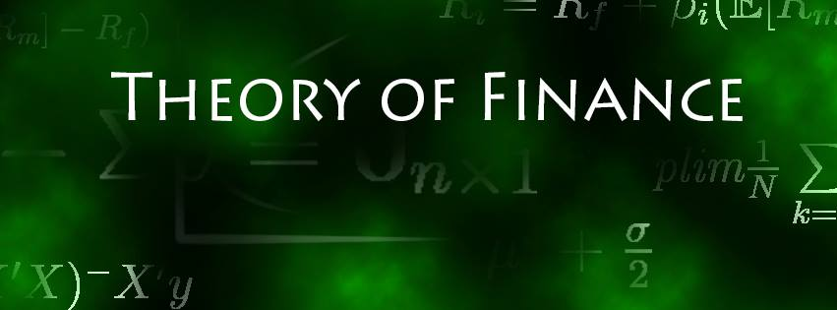

Solution Sheet on Problem Set 5

**Derivatives**

Deadline: 03.01.2021

**Solved by: Jonas Husmann, Niklas Kampe, Cyril Janak**

|  |  |  |
| --- | --- | --- |
| **Task** |  | **Points Earned** |
| 1. **Fee Pricing**   a)  mean, standard deviation, up- and down-factors (4 points) | **Statistics:**  Annualized Mean: 4.21%  Annualized Standard Deviation: 21.93%  Up-Factor: 124.52%  Down-Factor: 80.31% |  |
| b)  Three-year investment tree (8 points) | **3-year Binomial Tree:**  Upward probability (q): 50.0381%  Downward probability (1-q): 49.9619% |  |
| c) NPV cash-flows (6 points) | **NPVs Cash-Flows:**  Expected NPV of CFs in Period 1: 12’177.77  Expected NPV of CFs in Period 2: 7’530.55  Expected NPV of CFs in Period 3: 7’655.46 |  |
| d)  Utilities (6 points) | **Utilities Cash-Flows:**  Expected Utility from CFs in Period 1: 5’281.64  Expected Utility from CFs in Period 2: 3’426.9  Expected Utility from CFs in Period 3: 3’478.02 |  |
| e) Coupon of base-fee contract (10 points) | **Coupon:**  Utility-Indifferent Fixed Annual Coupon: 10’122.08 |  |
| f) Arguments on price setting and arbitrage (6 points) |  |  |
| 1. **Black-Scholes, Combined Strategy**   a) 3 shortfalls of the Black-Scholes model (6 points) | 1. **Usage of BS for American Options**   The baseline BS Model can only be used to calculate the price of European Calls/Puts, i.e. options that cannot be exercised during their lifetime, but only at settlement date. However, since – for most options traded – there is no desire to execute them during their lifetime, this issue is not that big of a problem. See also Figure 20.19 and 20.20 from the lecture notes for this reasoning:       1. **Assumes dividends, volatility and risk-free rates to remain constant over the option’s life**   The formula for Call and Put prices is static and therefore does not consider changes in volatility, risk-free rate or dividends of the underlying, when calculation the price of the option. Especially volatility can change within days and therefore influences the price of options strongly.  E.g., changes in VIX over period of a month (source: Chicago Board Options Exchange)     1. **Assuming lognormal distributions**   Lastly, as the formula (see 2b) shows, the model relies on the assumption of lognormal distributions (i.e., prices of the underlying asset at maturity are lognormally distributed), which is not satisfied in practice. Reasoning for this assumption is, that underlying prices follow a generalized wiener process with constant drift and variance. |  |
| b)  Prices of call and put options (4 points) | Formula used for European Call Price (underlying without dividends): $$C=S*Φ\left(d_{1}\right)-e^{-ym}*K*Φ\left(d_{2}\right)$$ Where: C = Call Price S = Spot of underlying $Φ\left(.\right)$ =  y = risk free rate  m = maturity (measured in the same entity as y)  K = Strike  And $$d_{1}=\frac{\log\left(\frac{S}{K}\right)+\left(y+\frac{σ^{2}}{2}\right)m }{σ\sqrt{m}}$$ And $$d_{2}=d_{1}-σ\sqrt{m}$$ And for European Put Price: $$P=K*e^{-ym}*Φ\left({-d}_{2}\right)-S*Φ\left(-d_{1}\right)$$ Given the data and strikes we get the following prices for our options: |  |
| c) Greeks for the call option (10 points) | **Table of Greeks** |  |
| d) Option strategy value, graph and aim of the strategy  (8 points) | Going long call and long put of the same underlying, with strikes above (call) and below (put) the Spot is a so called “Long Strangle” Strategy. Intuitively, we execute the call option, if the price of the underlying, goes above the strike (🡪 Betting on prices going up / being bullish). If the price is below the strike, the option expires. If the price goes below our put strike, we execute the put option (🡪 Betting on falling prices / being bearish). If the price is above the put option, the derivate expires.  The combination of put and call gives us unlimited profit, with prices very high/low. Since we go long, we have to pay a premium for the option, which also limits our losses to the initial payment. Therefore, we have a limitation in losses and limitless gains. We therefore bet/believe that the prices will either go up (strongly) or go down (strongly). However, we lose money if they remain close to the spot within the ranges of our strikes. In other words, we believe in high volatility, but unsure in whether direction it goes. This also translates into the payoff diagram, where the area below the red line shows our potential losses:    Doing the opposite (short both options) would be the opposite idea (betting on low volatility since we hope both options expire worthless, giving us the profit of the premium for going short.  The value of this strategy (holding 1 long call and 1 long put & ignoring transaction costs) is:180.14 |  |
| e) Risk-neutral probability for making profits (10 points) | Keeping in mind that the phi(d2) term in the Black- Scholes formula (21.3)–(21.4) is the risk-neutral probability that S_m > K, we reuse the formulas from above but given we’re looking to make a profit we’re now adding/subtracting the relevant option prices (C for the call option, P for the put option) to the spot i.e.:  Call Option $$d_{1}=\frac{\log\left(\frac{S-C-P}{K}\right)+\left(y+\frac{σ^{2}}{2}\right)m }{σ\sqrt{m}}$$ Put Option $$d_{1}=\frac{\log\left(\frac{S+C+P}{K}\right)+\left(y+\frac{σ^{2}}{2}\right)m }{σ\sqrt{m}}$$ And $$d_{2}=d_{1}-σ\sqrt{m}$$ Based on this we use the normal distribution of both d_2 that we found and add them up to get:  The risk-neutral probaility that this strategy will generate a profit is: 0.36 |  |
| f) underlying units to ensure delta-neutrality (6 points) | the Value of the portfolio is $$V = vS + M - L$$ we assume $M = 0$ and $L = - 1C - 1P$ given we're long one call and one put. Therefore, the equation becomes $$V = vS + 1C + 1P$$ given we're looking to be delta neutral need to take the derivative of this wrt S. This implies: $$v= Φ\left(d1_{call}\right)- Φ(d1_{put})$$ Using this formula we find that 0.4016 units of the underlying need to be bought such that the position is delta-neutral. |  |
| g) Formula for new strike prices and results of the estimate (10 points) | We are looking to have a 70% risk neutral probability that at least one of the options is in the money. Given both options contribute equally we want: $$Φ\left(d2_{call}\right)= 1- Φ\left(d2_{put}\right)=0.35$$ The corresponding values according to the normal distribution are: $$d2_{p} = 0.385$$ $$d2_{c} = -0.385$$ To find the the strikes for the call option and the put option, respectively, we solve formula 21.4 back to get K. $$K=\frac{S}{e^{\left(d2+ σ^{2}\sqrt{m}\right)σ^{2}\sqrt{m}-\left(y+\frac{σ^{2}}{2}\right)m)}}$$ We set in the respective $d2_{p}$ and $d2_{c}$ and get:  The strike for the call option needs to be set at 12528.72  The strike for the put option needs to be set at 12163.48 |  |
| h) New option prices & total value of strategy (6 points) | The option price for a European Call, with Strike 12528.72, is: 115.96  The option price for a European Put, with Strike 12163.48, is: 107.91  The overall strategy value is : 223.87 |  |